**Produce evidence of having professionally relevant FIVE (5) of the following online: blog, vlog, Facebook account, Twitter account, Instagram account, WhatsApp account, LinkedIn account, etc.**

Whatsapp account

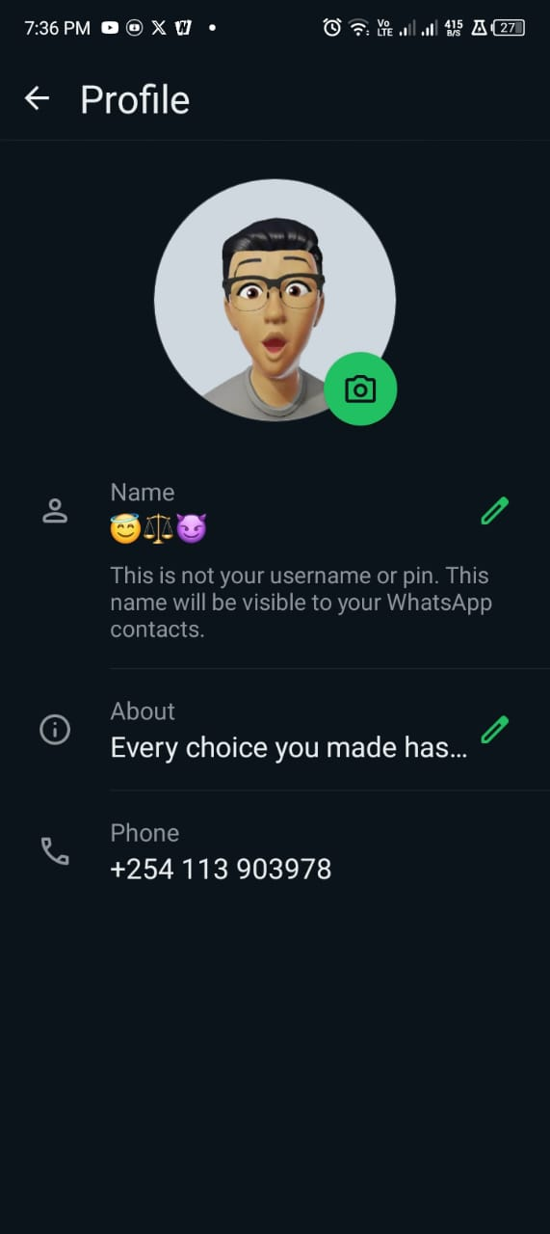

Facebook Account

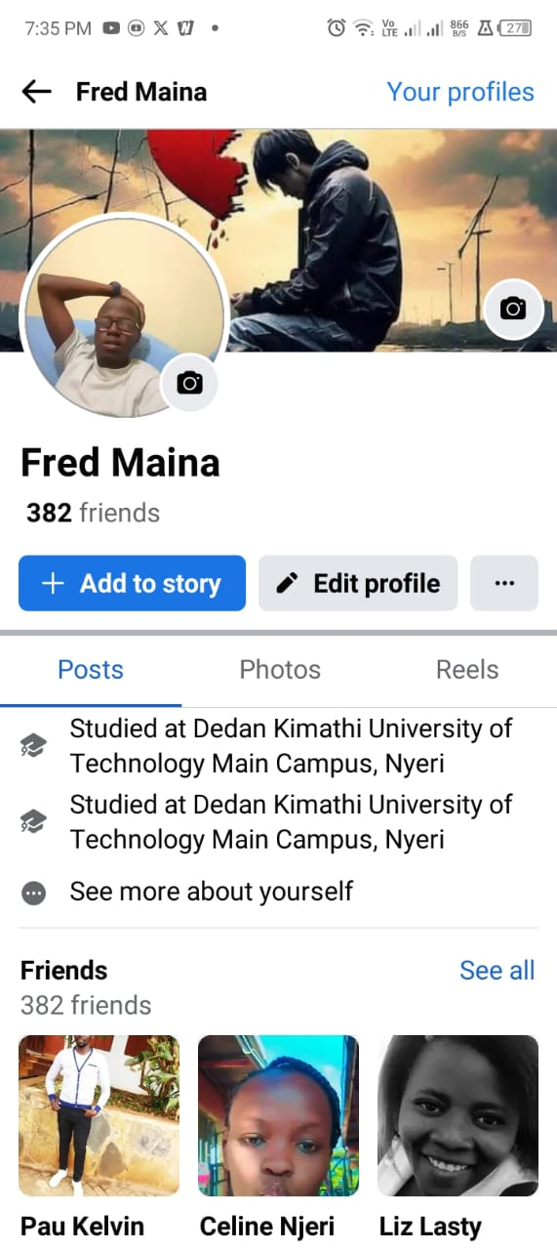

X Account

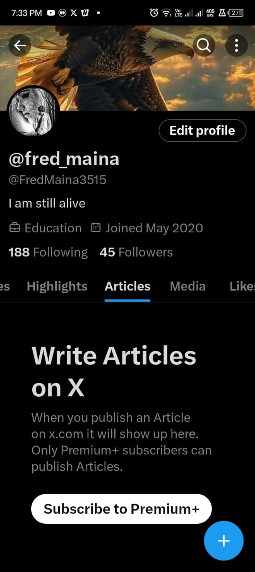

Instagram Account

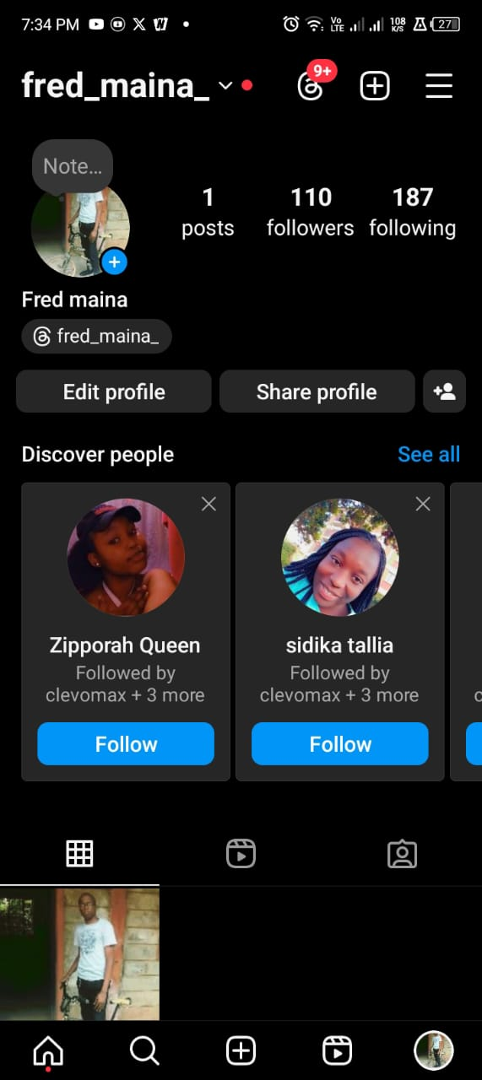

linkedIn Account

